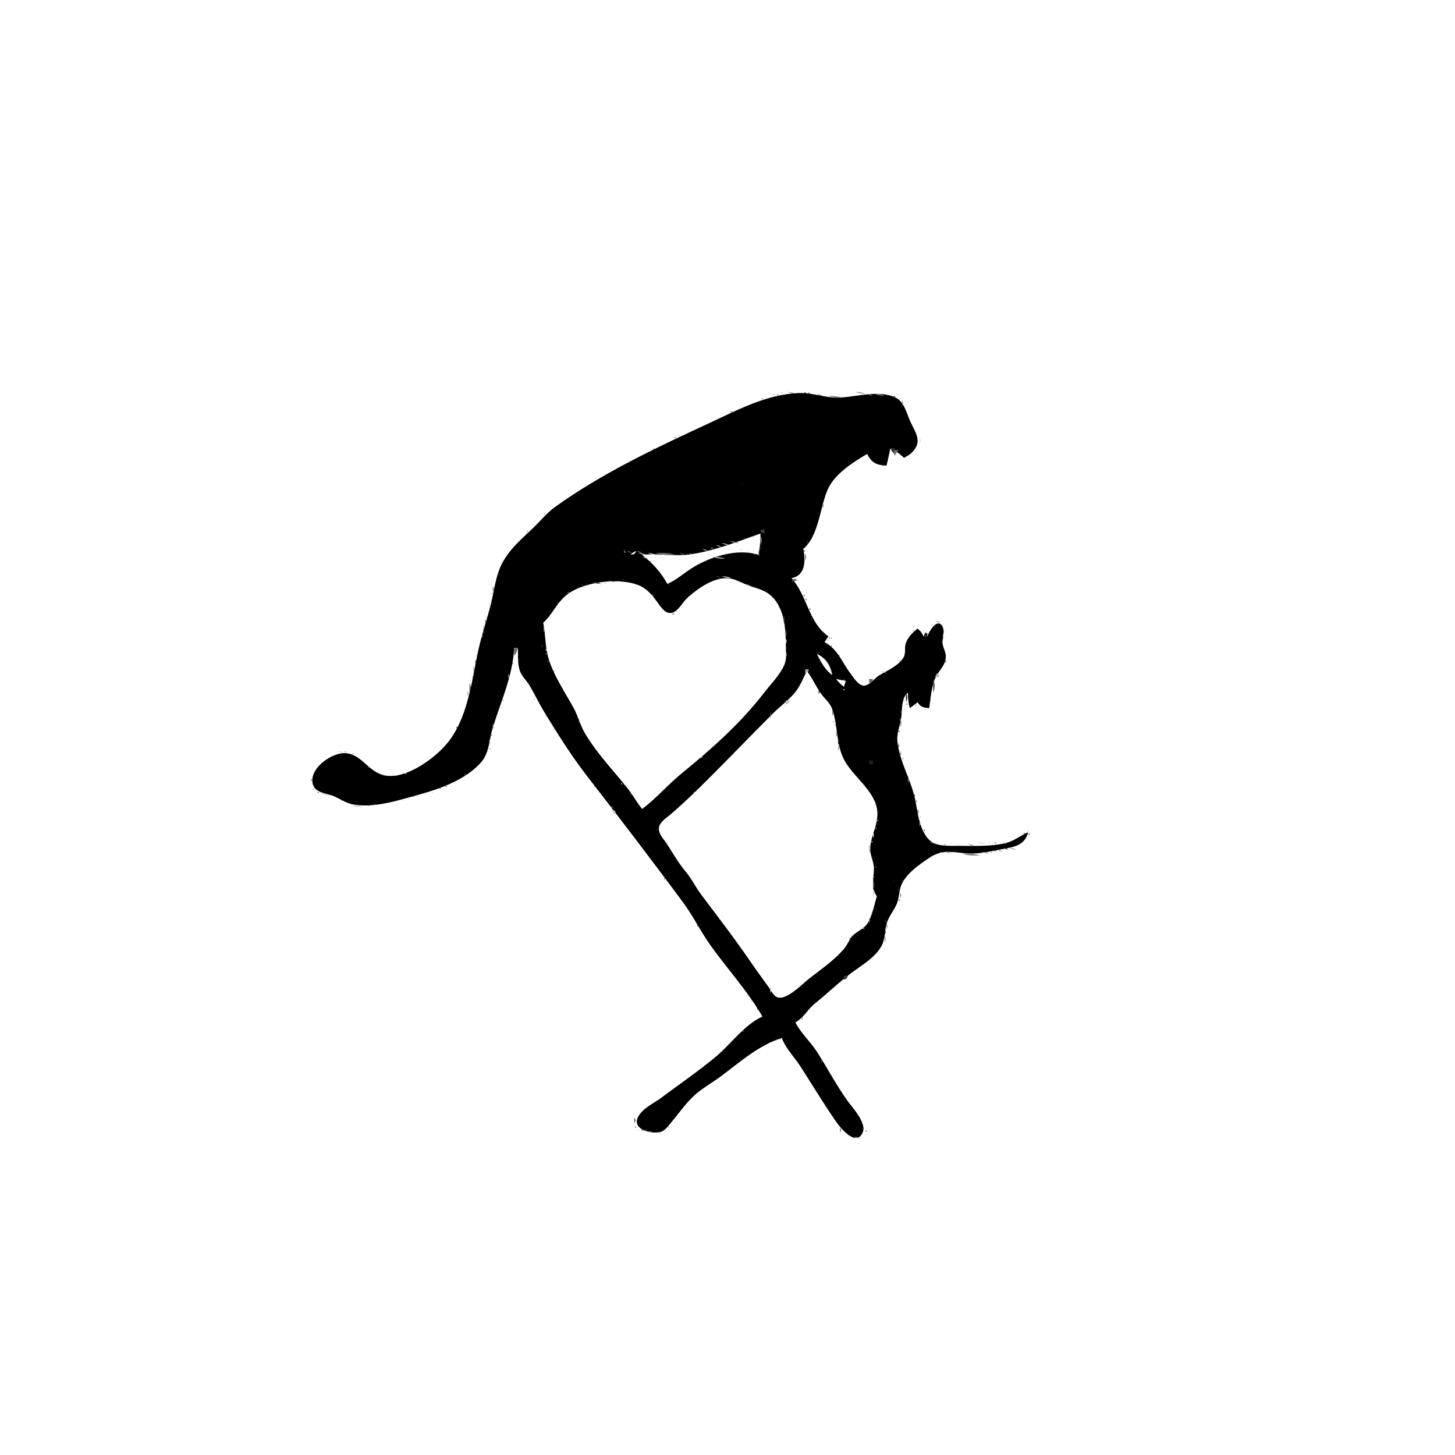
December-March Hunt Preparation and Equipment

We recommend all participants in hunting activities are in good shape as well as health. The Frank Church Wilderness is very rugged terrain. We may increase elevation from anywhere from 500 ft-3000ft. Most of the hunt is on horseback, but there is still plenty of hiking and walking involved in our hunts. We recommend you shoot your gun and are familiar with it prior to arriving. It makes your hunt much easier for you.

- What to Expect: In Idaho the weather is likely to change from hot to cold or Cold to hot without much warning. These early hunting months, prepare for warmer days and cooler nights (HEART X DOES NOT GUARANTEE ANY WEATHER SITUATION).
What to Bring
- Rifle sighted in 2 inches high at 100 yards.
- 40 rounds of ammunition, preferably the same as you have already practiced with.
- We recommend the biggest gun you feel comfortable shooting.
- Pair of quality binoculars preferably waterproof, 10x42s are the best.
- 2 BIC lighters that fits in your pocket
- One good hunting knife.
- One good day pack - keep your day-pack small and light, the guides have the tools necessary to field dress your game.
- 2 head lamps with extra batteries
- Camera
- If you wear contacts or glasses, try to bring an extra set.
- Personal items - washcloth, toothbrush, chap-stick, deodorant, prescriptions, headache medicine, ANY DAILY MEDICATION NEEDED (diabetes medication, blood pressure, heart medicine etc.) and any other personal items we may have missed.
- Sleeping bag that is good down to 0° below zero.
- Rain gear - preferably not plastic as it is very noisy and rips easily.
- Good pair of leather boots already broken in, Pack Boots, or insulated boots for our late season hunts.
- A pair of shoes for around camp such as crocks, tennis shoes etc.
- 1 to 2 water bottles 16 oz. apiece.
- Fire paste or some sort of fire starter. Below is a link to what I carry.
- 2 Solar blankets. *They are light weight and pack easy in your gear.
- An extra pair of gloves. Contained in a ziplock bag in day pack.

*All your gear should fit in one duffle bag weighing 80lbs max. Not including your sleeping bag. Please no bags longer than 36 inches. Soft Duffels pack easier.

*Beer, wine or liquor of your choice * we do not provide any alcohol.

*Any special medications needs to be kept in your day-pack.

*Game bags: four for elk, two for deer and two for bear.

What we use:
We are often asked about our personal gear. THIS IS NOT A REQUIREMENT TO COME HUNT. THESE ARE JUST WHAT WE USE all hunters are welcome to use any brand of equipment they are comfortable with.

EXO pack https://exomtngear.com/collections/k4/products/k4-3600-pack-system

Kuiu Boot Gaiter https://www.kuiu.com/products/yukon-hd-gaiter-valo-camouflage?variant=40536103223454

Vortex 10X42 binos https://vortexoptics.com/vortex-diamondback-hd-10x42-binoculars.html

Schnees boots https://schnees.com/granite-200g-mens/

Outer layers we have a combination of Kuiu gear as well as First Lite.
Fire paste -https://www.amazon.com/Coghlans-8607-Fire-Paste/dp/B000QJFKIM/ref=sr_1_fkmr1_1?dchild=1&keywords=culligan+fire+paste&qid=1575134555&sr=8-1-fkmr1
Crampons are a priority and highly recommended. I would get the ones on the link below. https://www.amazon.com/Hillsound-Cypress6-Traction-Device-Black/dp/B004BN97IS/ref=sr_1_8?crid=3IPLD17BBFSNO&dchild=1&keywords=hillsound+crampons&qid=1575134676&sprefix=hillsound+cra%2Caps%2C239&sr=8-8

Solar Blankets https://www.amazon.com/ANMEILU-Emergency-Blankets-Survival-%EF%BC%8CMarathons/dp/B07GLCYR5S/ref=sr_1_10?dchild=1&keywords=solar+blackets&qid=1575134794&sr=8-10

